Adjust ѱ
Pre4Sim6 psi 02
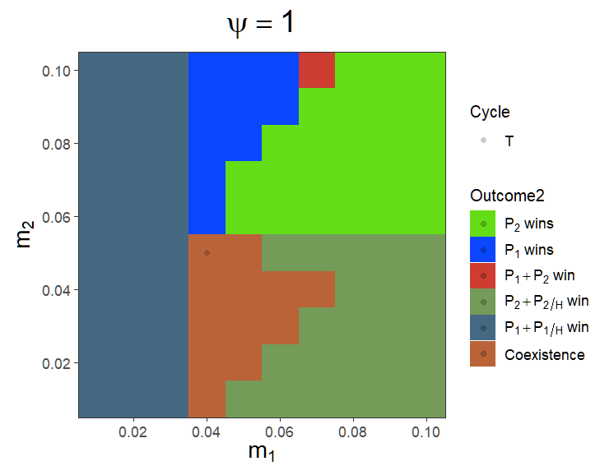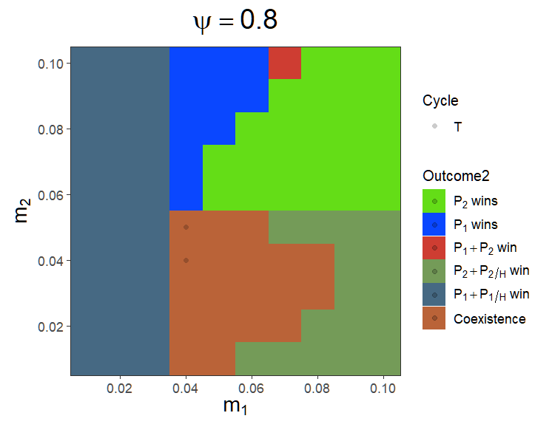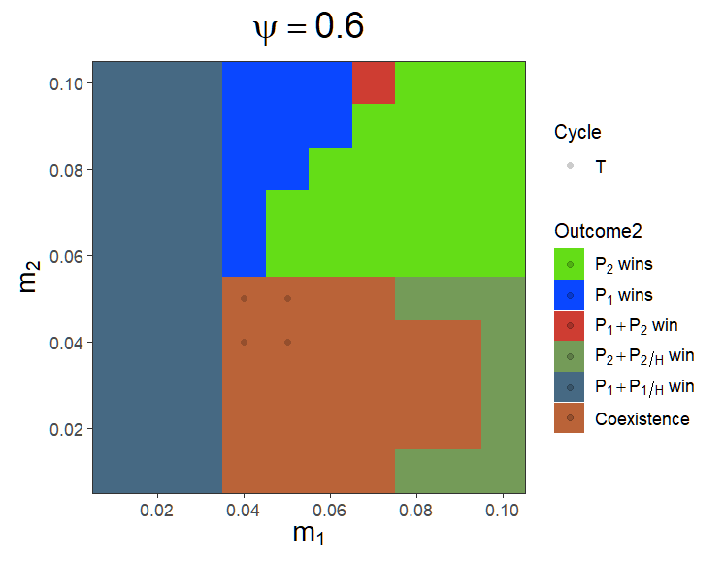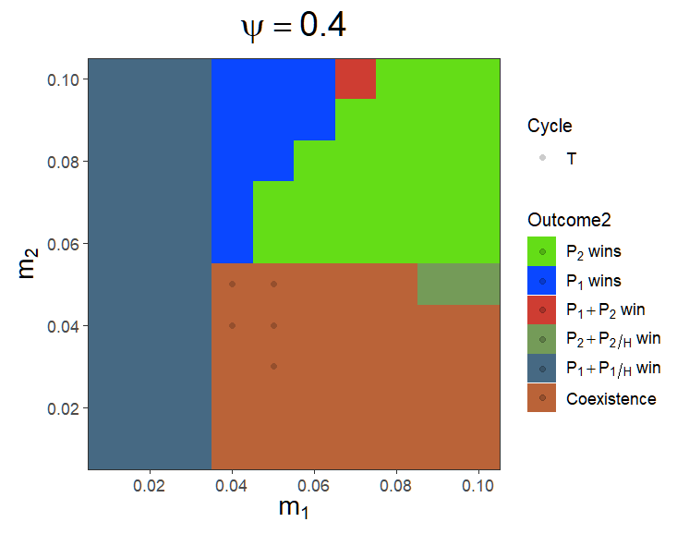

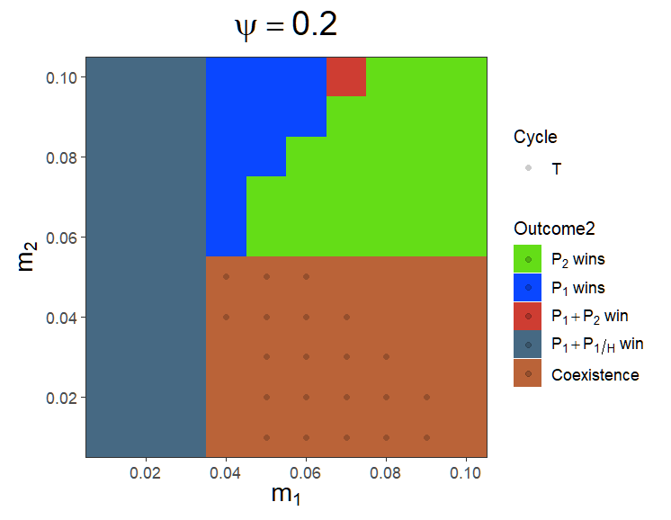
As ѱ increased, an increase in m₁ will not exclude P₁
資源被釋出? Ѱ is also a critical factor that affect pathogen resurgence?
Need to know the coexistence and monoculture criteria.

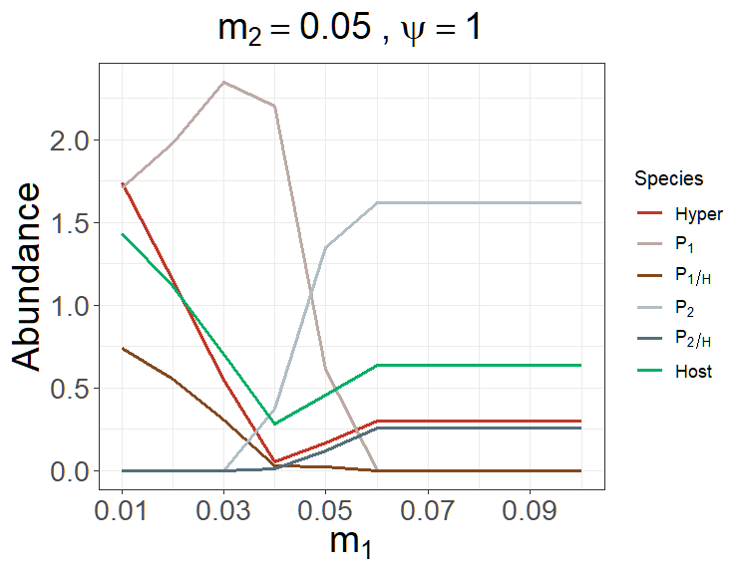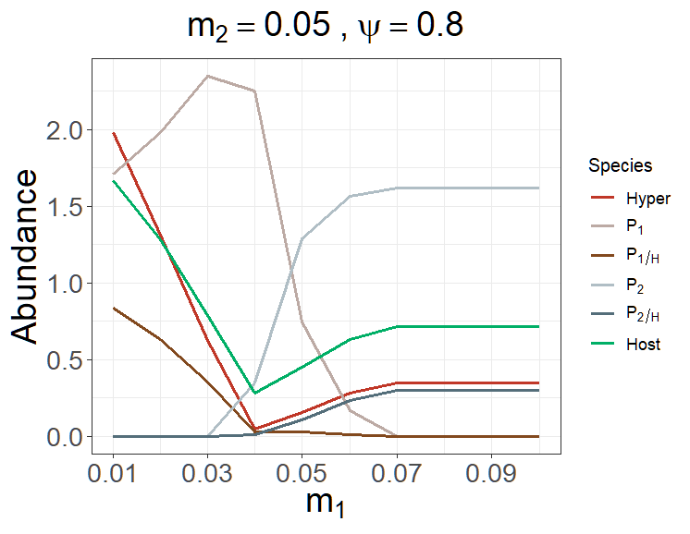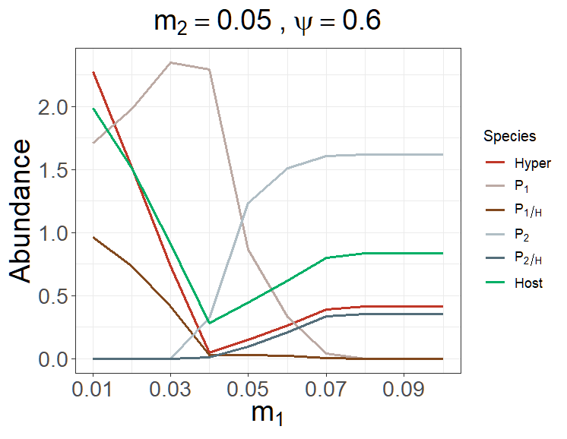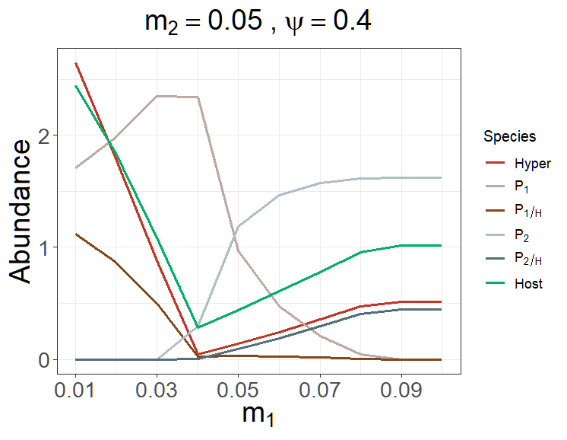
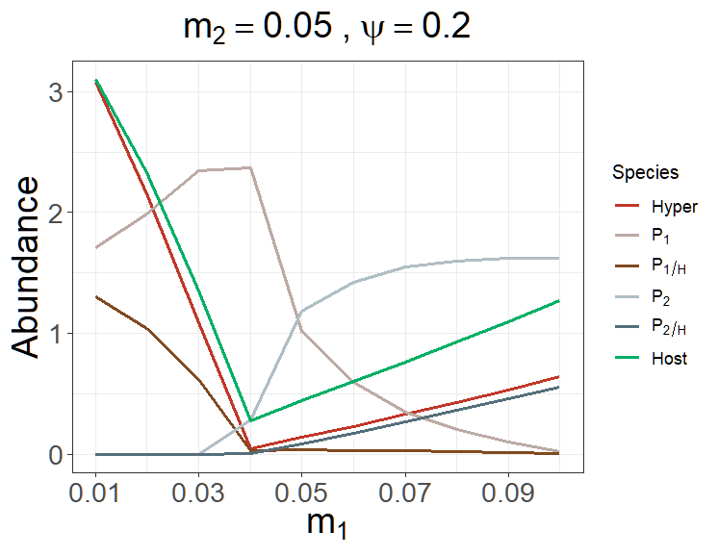
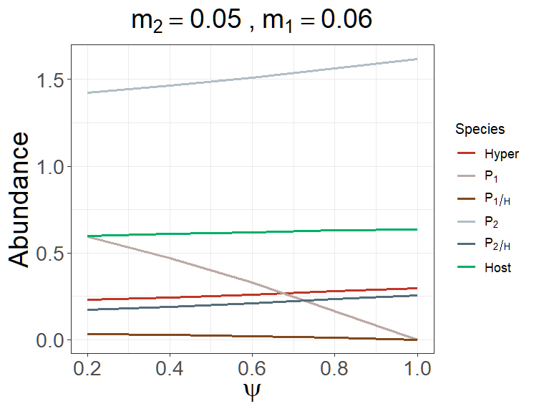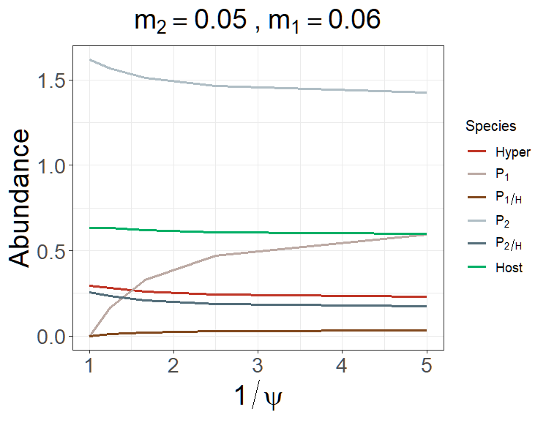
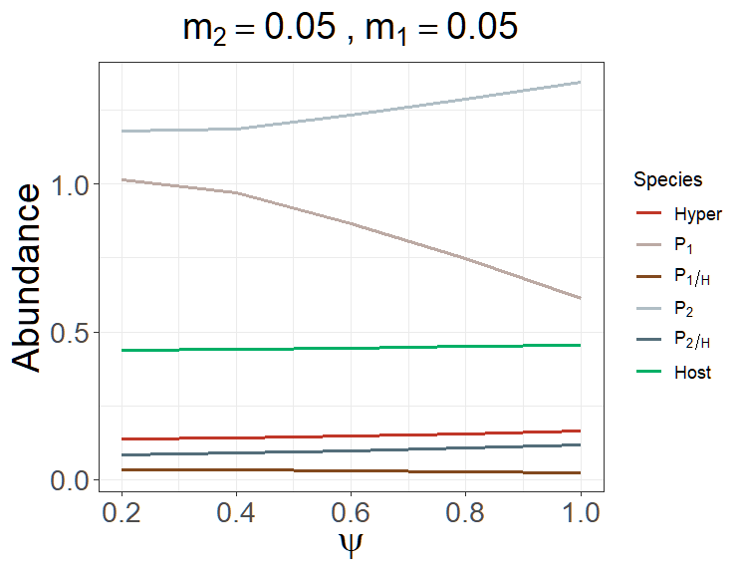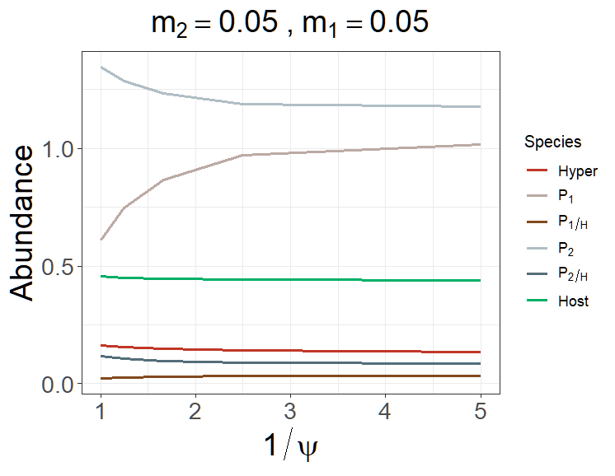

Pre4A1
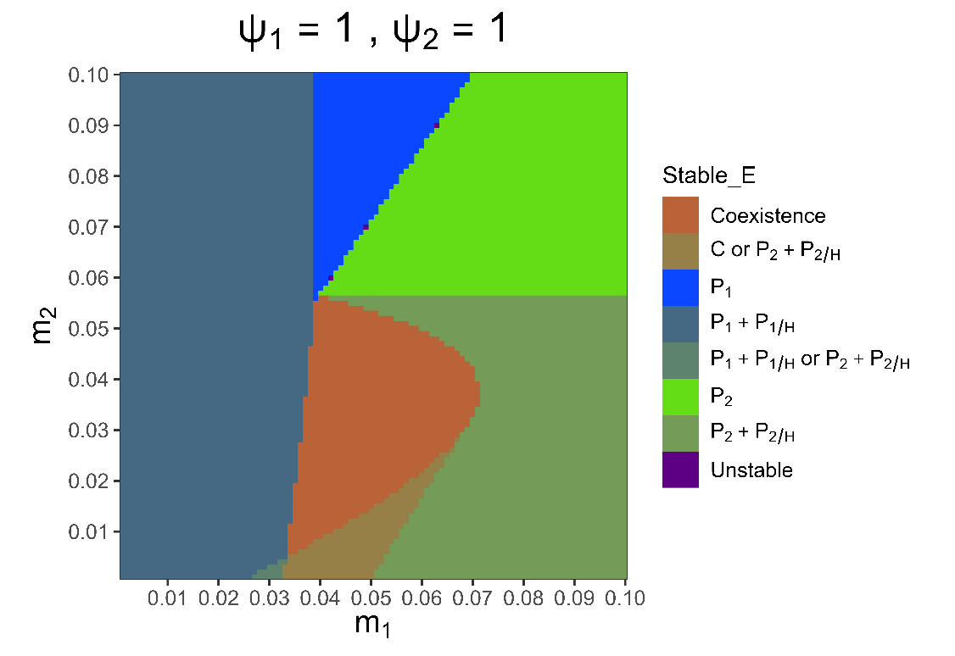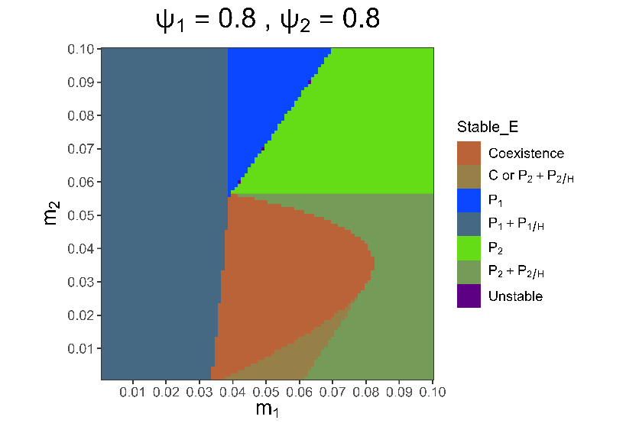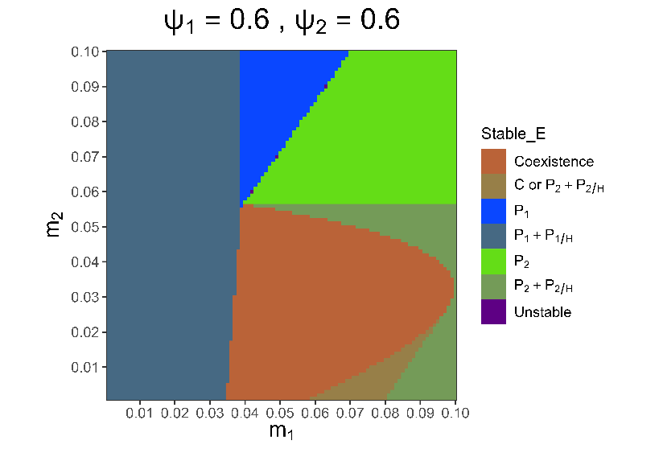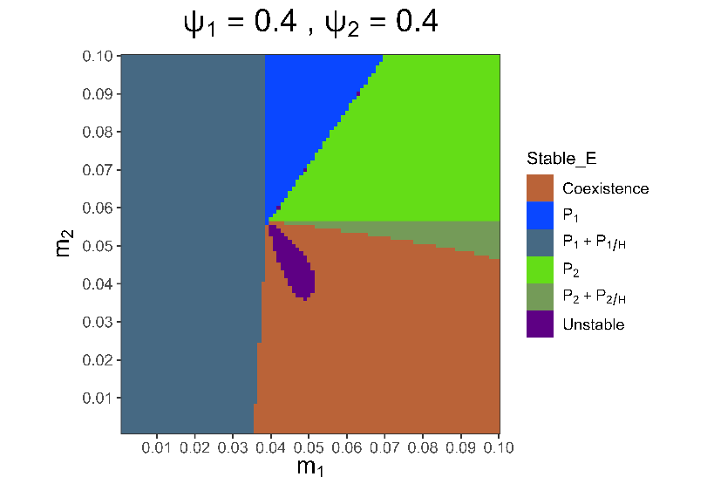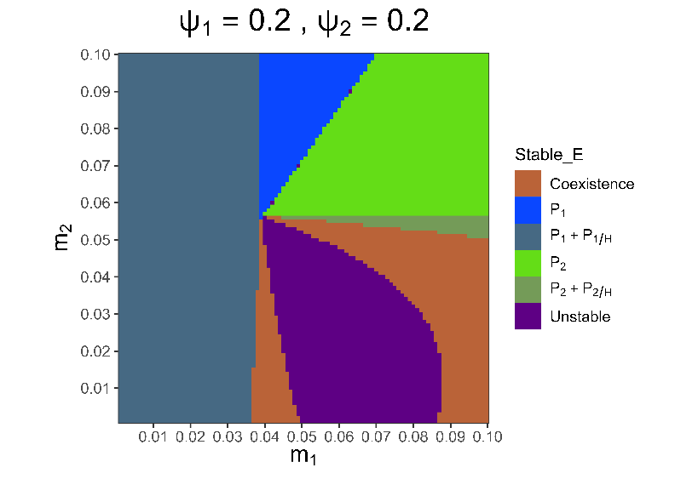
The alternative stable states are displayed with a mixed color of the two equilibria on the heatmap.
The parameter space can be separated into seven parts, some of which can be divided with IGR.

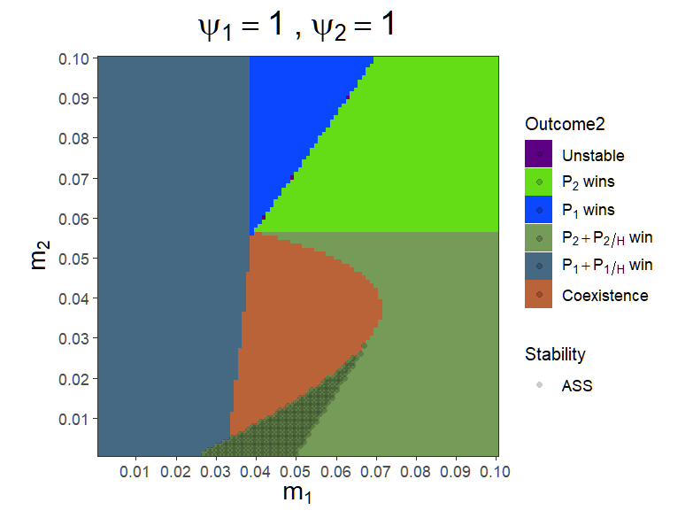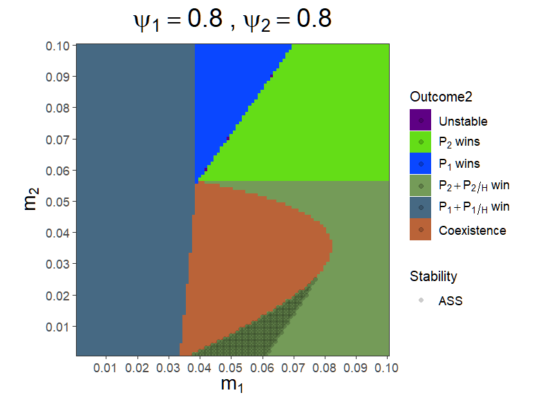
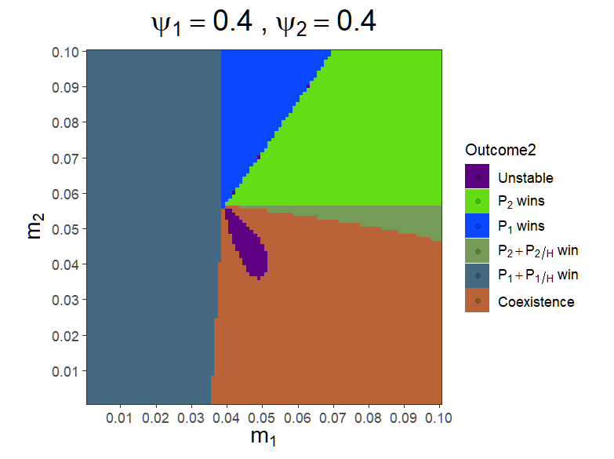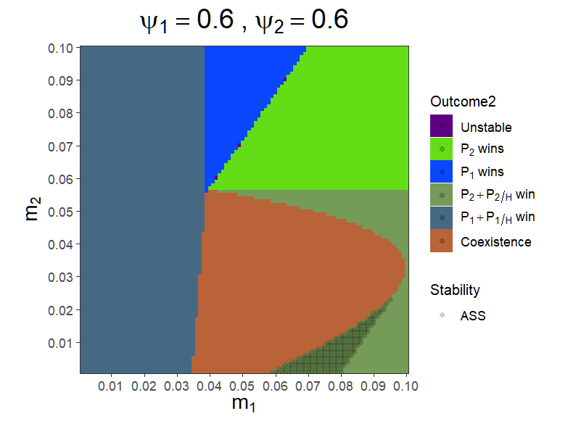
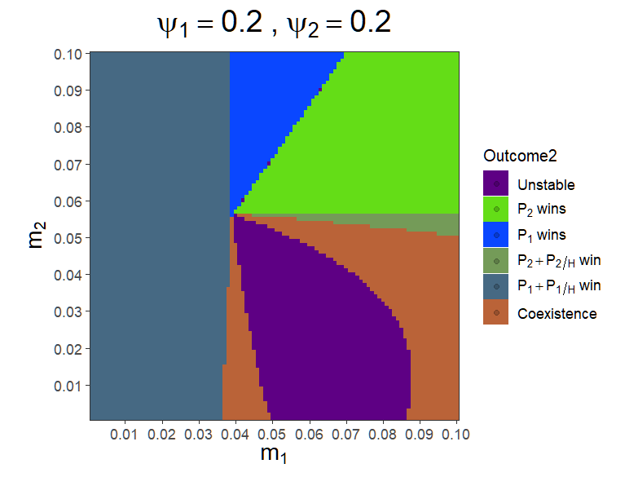

When $ψ=1$ (no hypovirulence effect), the figure can be separated into 6 parts.
When $m_{1}$ is low (approximately < 0.035), $P_{1}+P_{1/H}$ always win due to their low mortality

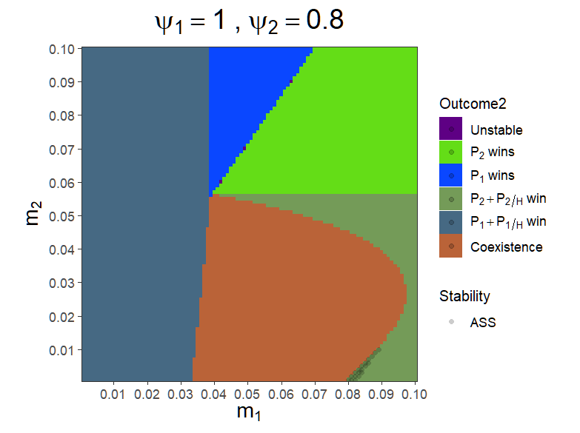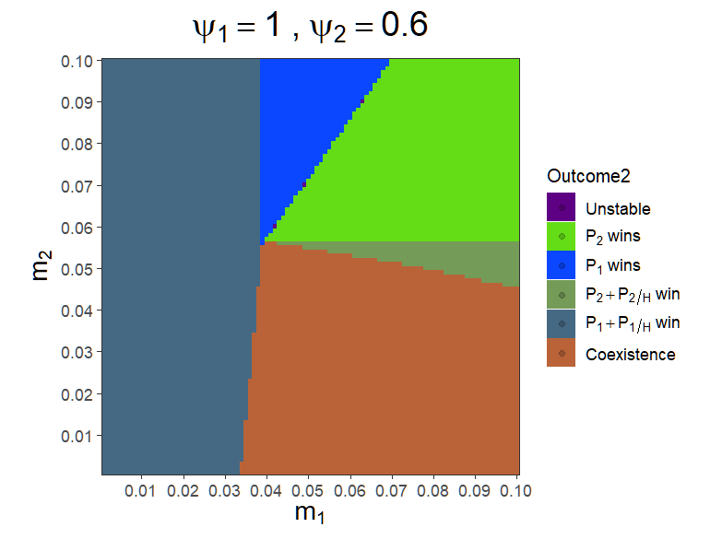
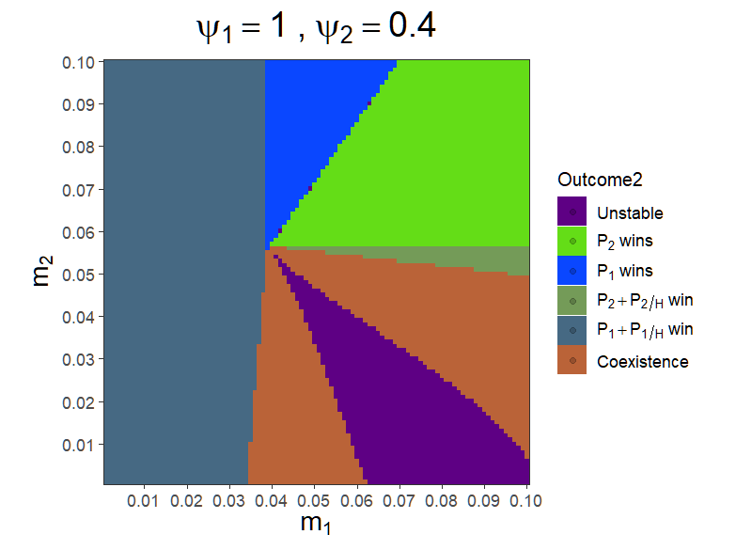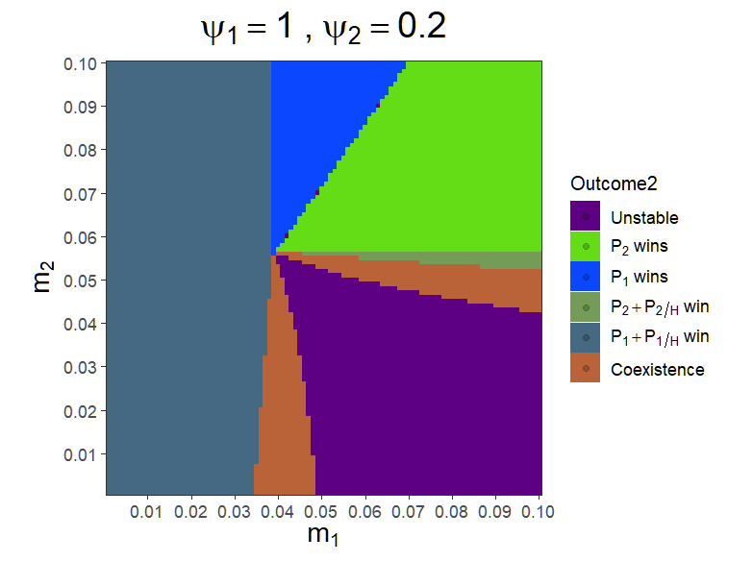

(Here, $P_{1}$’s $α$ is lower than $P_{2}$’s $α$)
原先預期：當$ψ$減少時，毒力弱的 strain 會越來越容易贏or共存。
當$ψ_{1}$減小時，$m_{1}$的增加，不會這麼容易讓$P_{1}$死掉，反而增加共存範圍

Question: When can H cannot persist? Boundaries?

Pre4A1 (correct)
parms <- list(r = 1, K = 10,
a1 = 0.35, a2 = 0.5, psi1 = 1, psi2 = 1, e1 = 0.5, e2 = 0.5,
b1 = 0.2, b2 = 0.45, m1 = 0.05, m2 = 0.05, e1H = 0.5, e2H = 0.5,
o1 = 0.8, o2 = 0.8, h1 = 1, h2 = 1, c1 = 0.9, c2 = 0.9, d = 0.03, DL = 0)

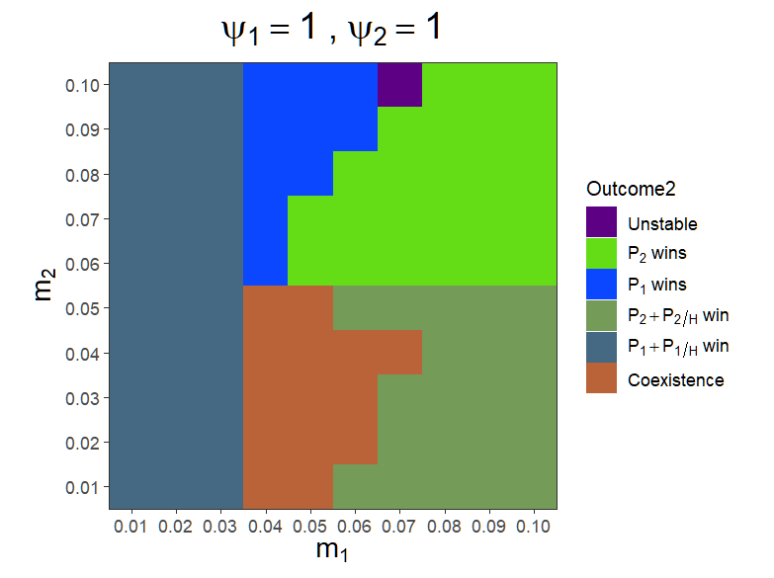
There is an alternative stable state when m1 = 0.06, m2 = 0.02 and m1 = 0.05, m2 = 0.01

